SIGNALS AND SYSTEMS
Course Code: ECA0305
CO1 – EXPERIMENT 4
Experiment 4.1
Title: Discrete-Time System
Aim:
To analyze the behaviour of a discrete-time system described by the difference equation y(n) = x(n) + x(n-1) and to observe its output sequence for a given input.
Apparatus Required:
- Personal computer
- MATLAB software
Procedure:
- Open MATLAB and create a new script file.
- Clear the command window and workspace using clc, clear and close all.
- Define the sample index n = 0:10 and the input sequence x = [1 2 3 4 5 6 7 8 9 10 11].
- Implement the system y(n) = x(n) + x(n-1) using the filter command, y = filter([1 1],1,x).
- Display the output sequence using the disp command.
- Plot the input and output sequences using stem in a 2x1 subplot layout.
- Add grid, title, xlabel and ylabel to each plot.
- Run the program and compare the input and output sequences.
Program:
% Discrete-Time System
clc;
clear;
close all;
% Input sequence
n = 0:10;
x = [1 2 3 4 5 6 7 8 9 10 11];
% Discrete-Time System
y = filter([1 1],1,x);
% Display output
disp('Output Sequence:');
disp(y);
% Plotting
figure;
subplot(2,1,1);
stem(n,x,'filled');
grid on;
title('Input Sequence x(n)');
xlabel('n');
ylabel('Amplitude');
subplot(2,1,2);
stem(n,y,'filled');
grid on;
title('Output Sequence y(n)=x(n)+x(n-1)');
xlabel('n');
ylabel('Amplitude');

Output – Experiment 4.1:
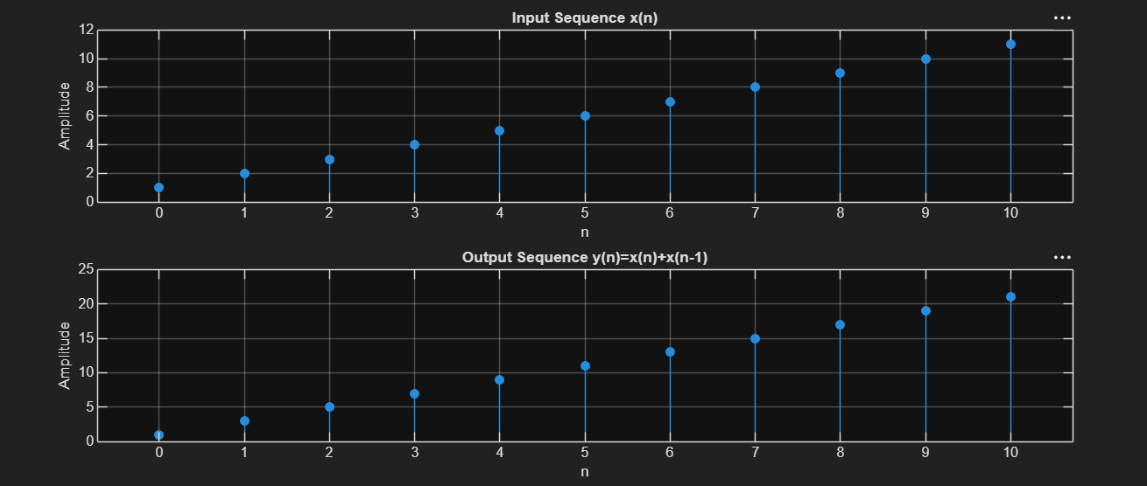
Result:
The discrete-time system y(n)=x(n)+x(n−1) was implemented using MATLAB. The output
sequence was obtained by combining the present and previous input samples, and the input
and output signals were displayed using stem plots.

LABORATORY PERFORMANCE ASSESSMENT RUBRICS:

Objective | Assessment Criterion | Excellent – 4 | Good – 3 | Satisfactory – 2 | Needs Improvement – 1 | Weightage | Marks(10) | Marks obtained
(i) To verify the linearity and time-invariance properties of continuous-time and discrete-time systems using suitable input signals and system responses. | Linearity Verification (Homogeneity & Additivity) | Correctly applies the homogeneity test and the additivity test (or the combined superposition test) to every CT and DT system. Chooses suitable input signals and scaling constants, compares the two responses accurately, and concludes linear or non-linear correctly. | Applies the linearity tests correctly to most systems, with minor errors in the choice of inputs, algebra or comparison. | Performs a basic linearity test (only one of homogeneity or additivity, or only some systems) with noticeable errors, and needs guidance. | Unable to apply or interpret the linearity test. | 20 | 2
 | Time-Invariance Verification (Time-Shift Test) | Correctly applies the time-shift test, comparing the response to the shifted input with the shifted output for every system. Handles systems with time-scaling or time-varying coefficients correctly and concludes time-invariant or time-varying correctly. | Applies the time-shift test correctly to most systems, with minor errors in shifting or comparison. | Performs a basic time-shift test with noticeable errors (for example shifting only the input or only the output), and needs guidance. | Unable to apply or interpret the time-invariance test. | 20 | 2
 | MATLAB Implementation & Numerical Verification | Writes correct MATLAB code with suitable time and index vectors to generate the test inputs, the system responses, the scaled, summed and shifted versions, and the plots. Computes numerical errors between the compared responses, and uses a tolerance to decide pass or fail. Plots have titles, axis labels and legends. | Code, plots and numerical comparison are correct, with minor errors in range, parameters, tolerance or labelling. | Code runs but has noticeable errors in vectors, shifting or error calculation, and needs assistance. | Unable to implement the tests or produce meaningful responses and plots in MATLAB. | 20 | 2
 | System Classification & Mathematical Justification | Independently classifies each CT and DT system as linear or non-linear and time-invariant or time-varying Supports each classification with correct mathematical working and with the waveform or error evidence from MATLAB. | Classifies most systems correctly, with minor errors or limited justification. | Gives basic classifications. Justification is incomplete or not linked to the test results, and needs guidance. | Unable to classify the systems correctly or justify the classification. | 20 | 2
 | Engineering Analysis, Record & Interpretation | Provides a technically accurate interpretation of the results and links them to the importance of linear time-invariant (LTI) systems Maintains a complete, well-organized record with code, plots, observations and conclusions. | Maintains a proper record with minor omissions. Interpretation is correct but brief. | Record and interpretation are basic or partly incomplete, and need guidance. | Incomplete record, limited or no interpretation of the results. | 20 | 2
 |  |  |  |  | Total | 100 | 0

